Experiment-1
Section-1

Name | Lastname | ID
Mehmet Ali | Kamalak | 150720062
Fuat | Akgül | 150722050
Beyazıt | Beloğlu | 150722039

Pre-LAB Work
- For the circuit given in Fig. 1, find and expression for the current flowing through the R7 resistor and for the output resistance Ro of the circuit. Ignore the Early Effect and assume that all the transistors are operating in active mode. (Hint: To calculate the current you do not need to know the value of the R7 resistor. To calculate Ro, you better review the common base configuration.)
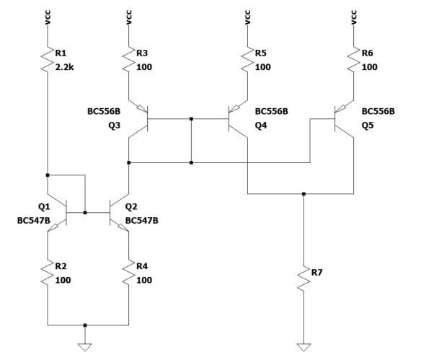
Ro

Figure 1
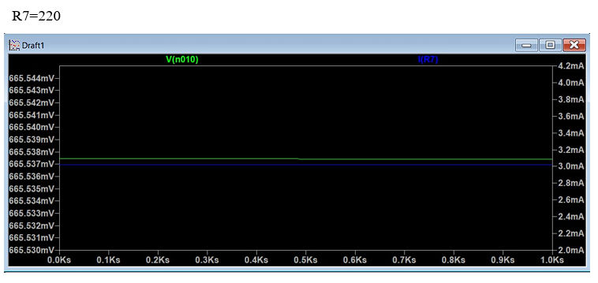
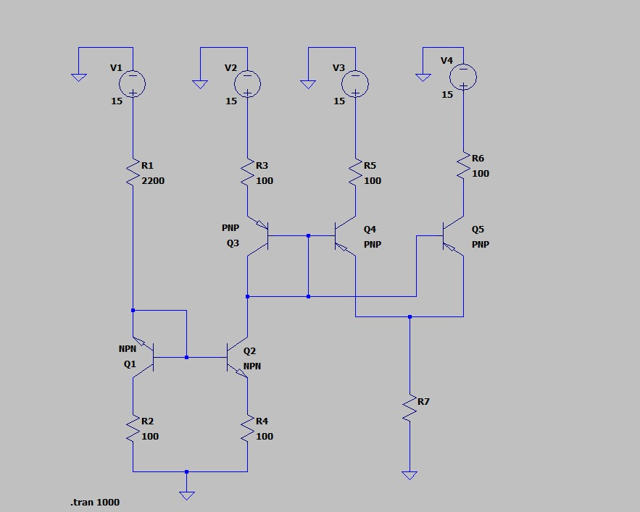

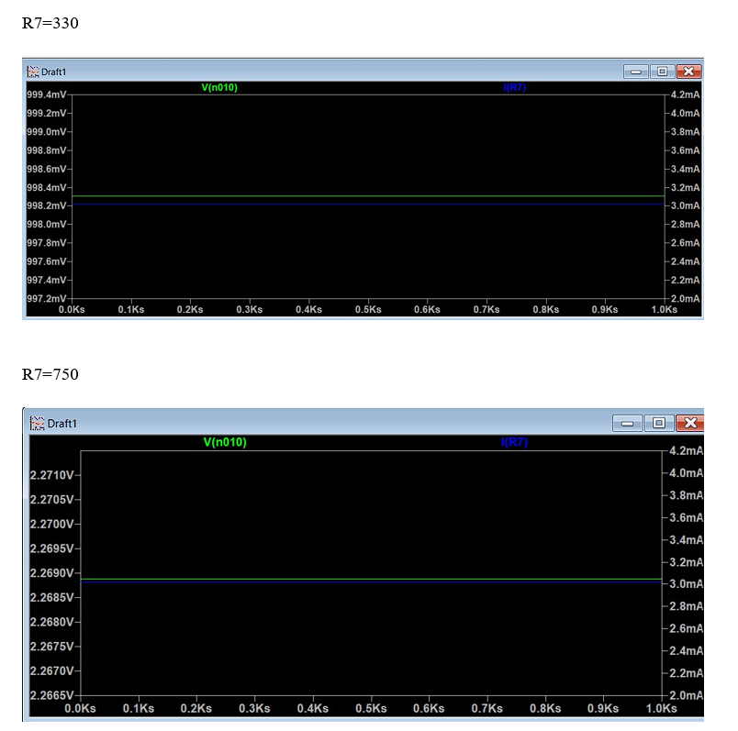

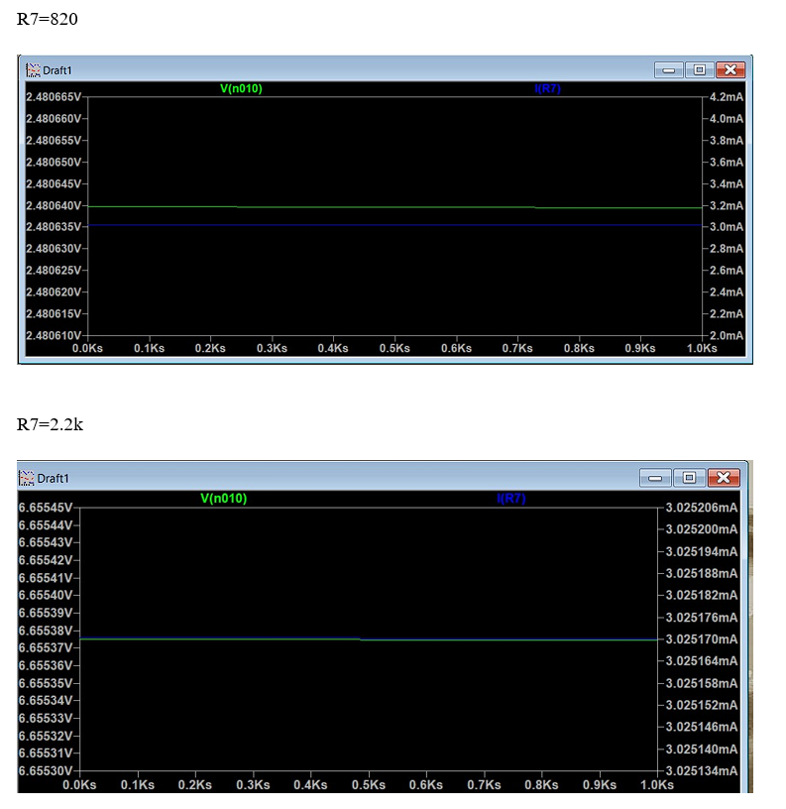

- Let Vcc be 15V and simulate the circuit in Fig. 1 with SPICE for the R7 values listed in Table 1. Measure the voltage across the R7 resistor and the current through it and fill the table.
Table 1: Simulation Results
R7 | V (R7) | Ix (R7) (mA) | Vy = Vcc – V (R7)
220Ω | 0.66553 | 3 | 14.33447
330Ω | 0.9983 | 3 | 14.0017
750Ω | 2.2 | 3 | 12.8
820Ω | 2.4 | 3 | 12.6
2.2kΩ | 6.65 | 3.1 | 8.35

- Based on the simulation results in Table 1 (ignore the last row) plot Ix (x-axis) vs Vy (y-axis) and fit a line. Calculate the slope of the line which will be the output resistance Ro.

$$R_{o}= \frac{∆V_{y}}{∆I_{x}}= \frac{-5.98}{-0.1}=59.8 Ω$$

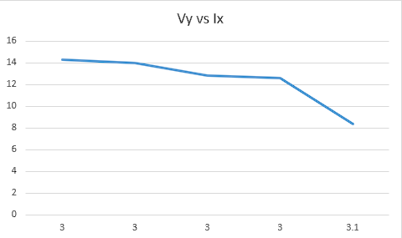
Plot:

Equipment/Component List
Table 3: Equipment/Component List
Equipment/Component | Model/Value | Count
Breadboard | - | 1
Resistor | 2.2kΩ | 2
Resistor | 100Ω | 5
Resistor | 220Ω | 1
Resistor | 330Ω | 1
Resistor | 750Ω | 1
Resistor | 820Ω | 1
BJT (npn) | BC547 | 2
BJT (pnp) | BC556 | 3
Multi-meter | - | 1
Voltage Source | 15V | 1
Probes & Cables | - | -

Experiment Procedure
- Set-up the circuit in Fig. 1 with the resistor values on the Fig. 1. Adjust Vcc to 15V. Values for the R7 resistor are given in Table 2. Measure the exact values of R7 resistors before connecting them to the circuit and fill the second column of the table. Connect the R7 resistor to the circuit, measure the voltage across it and fill the table.

Table 2

R7 | Measured (R7) | V (R7) | Ix = V (R7) / (R7) (mA) | Vy = Vcc – V (R7)
220Ω | 217Ω | 11.8 | 53.63636364 | 3.2
330Ω | 329Ω | 12.52 | 37.93939394 | 2.48
750Ω | 748Ω | 13.38 | 17.84 | 1.62
820Ω | 817Ω | 13.49 | 16.45121951 | 1.51
2.2kΩ | 2.19Ω | 13.88 | 6.309090909 | 1.12

- Based on the data in Table 2 (ignore the last row), plot Ix (x-axis) vs Vy (y-axis) and fit a line. Calculate the slope of the line which will be the output resistance Ro.
$$R_{o}= \frac{∆V_{y}}{∆I_{x}}= \frac{-2.048}{-47.3273}=43.95 Ω$$
Plot:

- Compare the measured quantities in Table 2 with your simulation results in Table 1 and calculations in part 1. When R7 resistor is set to 2.2k the current significantly changes. Comment on the reason of this change.
Answer:
When R7 resistor is 2.2K ohm, the current significantly changes because the transistor voltage difference became less than 0.7V and gets saturation.

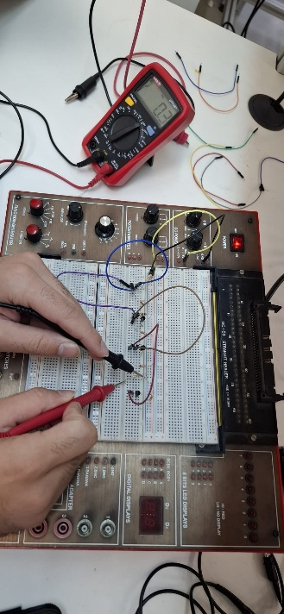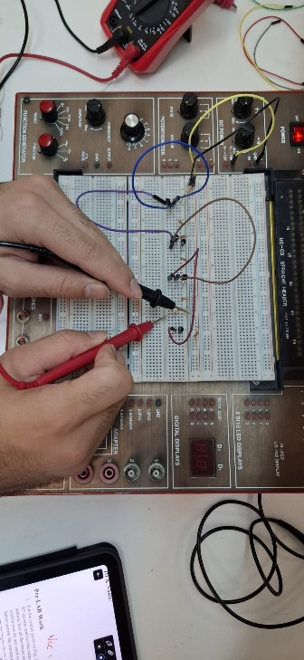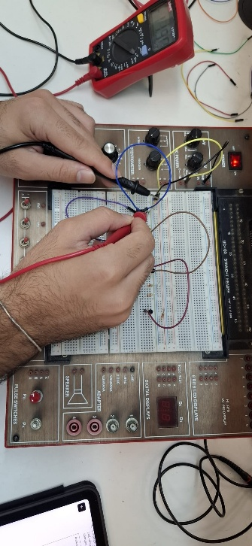

220 Ω 330 Ω 750 Ω

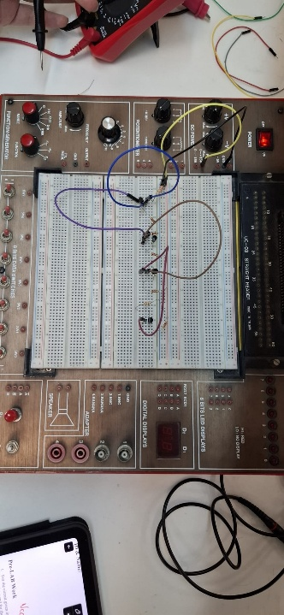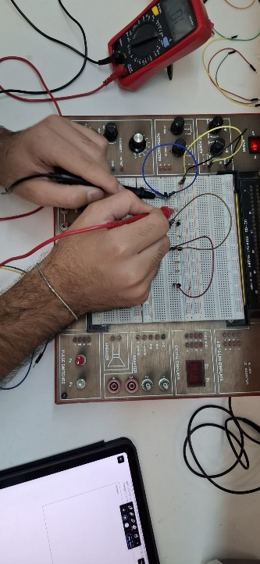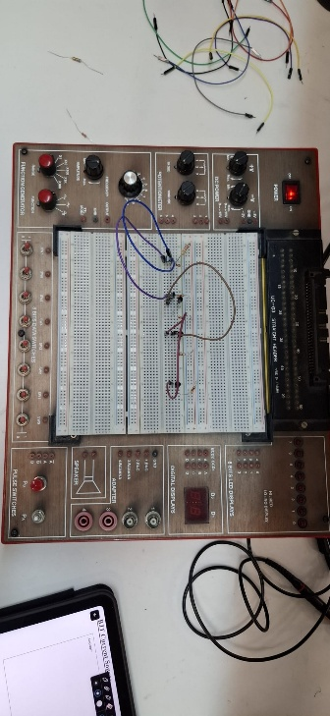

820 Ω 2.2k Ω Circuit

